**Lab_Day-1 ANP-C9180**

**(Introduction to Python)**

1. Installing Python on Windows

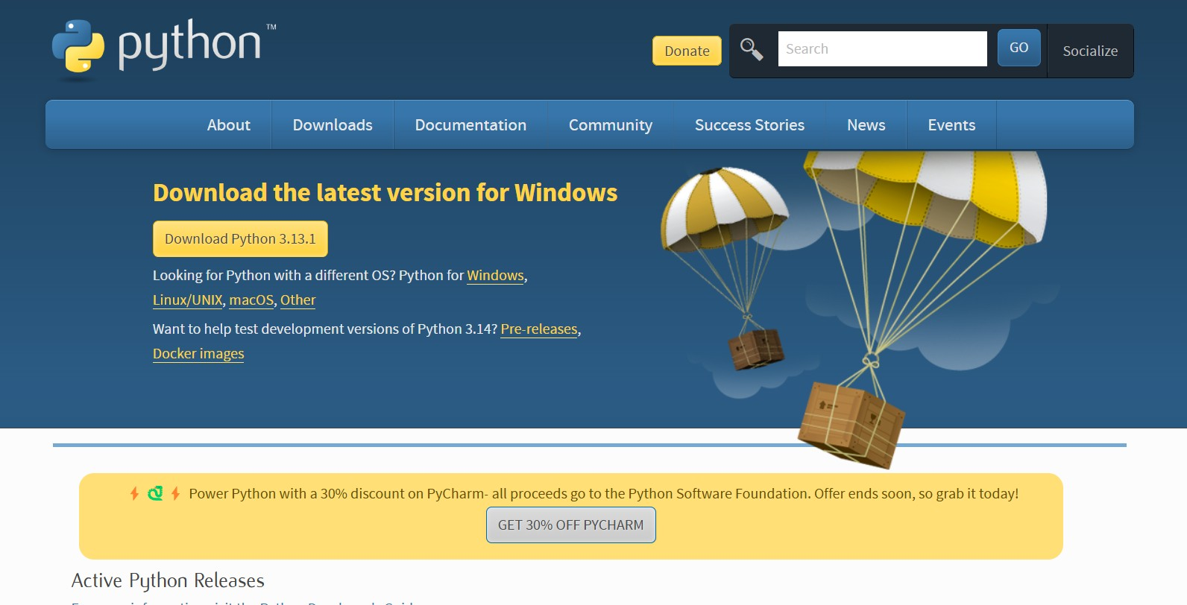

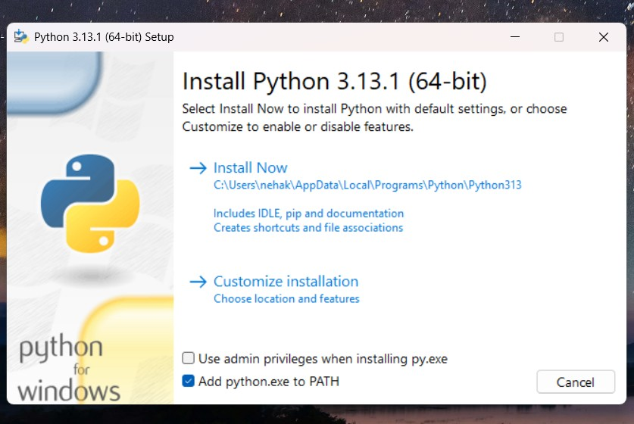

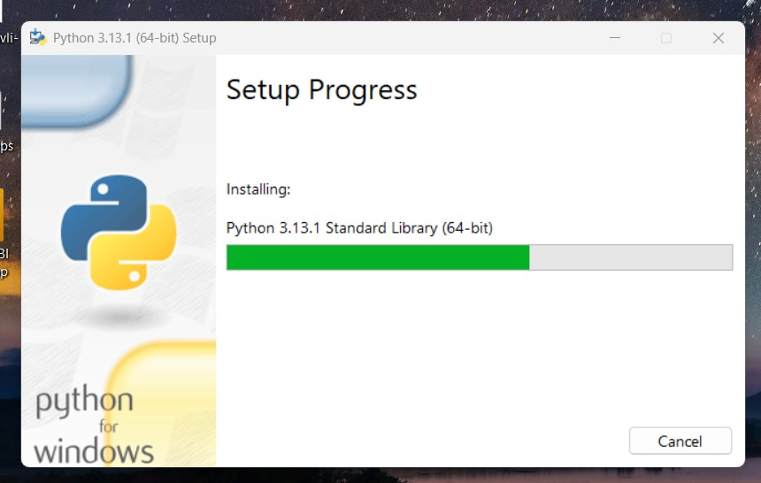

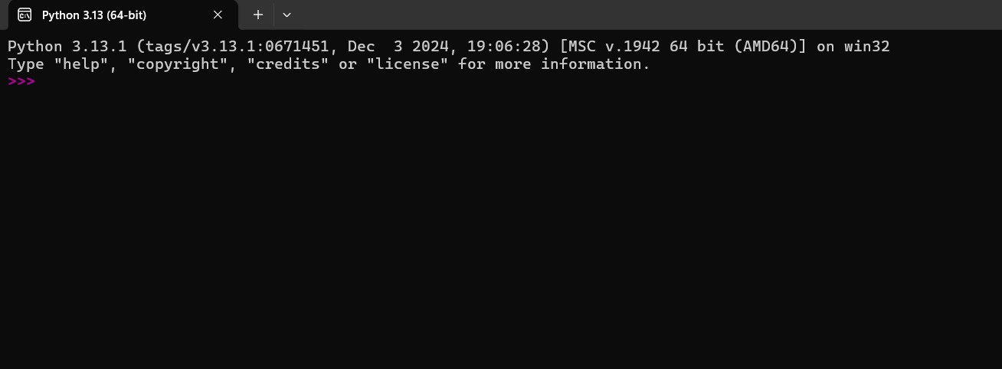

2. Demonstrate about Basics of Python Programming:

i. Running Python Interpreter:

